ME352 QUBE Motor Lab:
Frequency Response

Prof. Baglione, Prof. Luchtenburg
The Cooper Union Dept. of Mechanical Engineering
last updated: 10/22/25

1 Overview
In this lab, we examine the frequency response of the DC motor system by providing the motor with sinusoidal input voltages and observing the speed of the motor. We will ﬁnd that if the input to the system is sinusoidal, then the response (after transients decay) is also sinusoidal at the same input frequency, but with a varying amplitude and phase. The magnitude and phase of the response is dependent on the forcing (input) frequency. We then compare the frequency response of the model with the actual system.

2 Goals
Our hands-on goals for today are to:
- Become familiar with the MATLAB bode (pronounced “bow-dee”) command, which plots the system gain (in dB) and phase (in degrees) versus the log of the frequency.
- Learn that for sinusoidal forcing one must wait for all transients to decay before true sinusoidal response is observed. The time that one must wait is equal to the time that it takes to establish steady state in a step response.
- Compare theoretical predictions of the frequency to empirical measurements.

Before leaving the lab make sure you have all the data you need to turn in your lab assignment.

3 Frequency Response Pre-lab and Lab Assignment

Pre-lab Assignment: System Model in MATLAB
Write down the DC motor system model (see lab 1) in either state-space or transfer function form. We stipulate that both are equivalent representations of the same input-output relationship.

- Enter your model in MATLAB by deﬁning the state-space (sys = ss(A, B, C, D)), or the transfer function model (sys = tf(K,[tau, 1])). Use the parameter values specified by the Qube Servo 2 manufacturer specifications given in previous labs.
- Once the system is input into MATLAB we can look at the step response by running the command step(sys). You should get a step response similar to your open-loop response from the previous modeling lab.
- Input the command bode(sys) to see what the frequency response looks like. In this lab, you will compare the experimental Bode plot to the Bode plot of the first-order model.
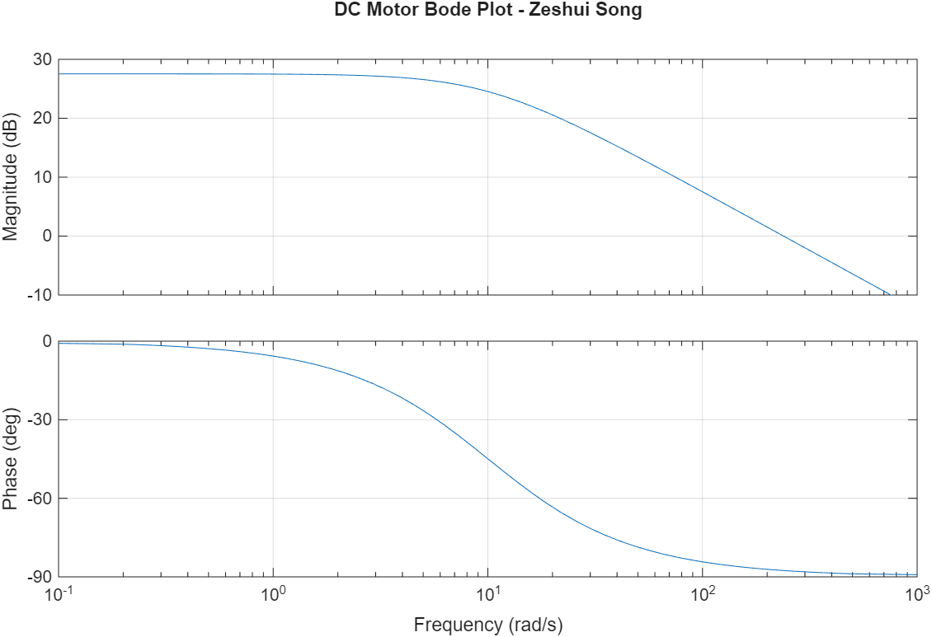

Lab Assignment: Capturing experimental sinusoidal response data
Firstly, follow the instructions on every monitor titled “Instructions to follow before every QUBE DC Motor Lab.” Navigate to the QUBE_STUDENT folder and click on the “open_loop_voltage.sltx” Simulink template and Create Model. Ensure that you open this with MATLAB version R2021. Save the template as a new Simulink file. Modify the model by changing the input to a sine wave as shown in Fig. 1. In the Simulation tab click Library Browser and find the sine wave block in the Sources. Reconnect the scopes and input voltage to theoretical model.
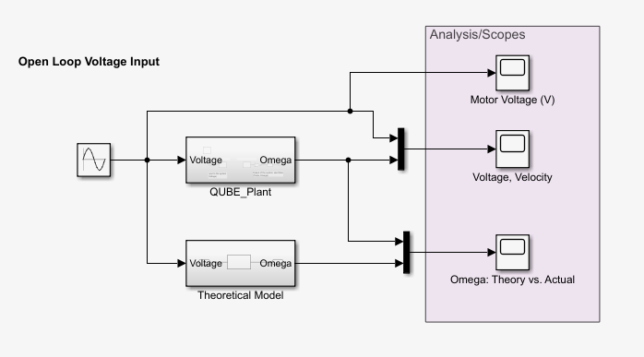
Figure 1: Block diagram for experimental frequency response of the Qube motor system.
In this lab, you will find the gain and phase at different input frequencies. You can do this by using the cursors in the Scopes and creating a table with your results at different input frequencies. Optionally, you may output the data to a .mat file using a Sink block and post-process the data in Matlab or Python.
Input the amplitude and input frequency in the Sine block. Run the Matlab parameter file and in the Simulink Hardware tab click Monitor & Tune. The LED light on the Qube motor should turn green and you should be able to view the input voltage and experimental angular velocity using the “Voltage, Velocity” scope.
- Set the amplitude of the Sine wave to 1 Volt and frequency to 1 rad/s. View the voltage and angular velocity scope and observe the steady-state response once the transients die out. Note the maximum motor angular speed and compare this to the calculated motor gain K and the experimental gain determined in lab 1. Is the angular velocity response purely sinusoidal? Why or why not? Pay attention to units of frequency as some Simulink blocks input rad/s and some Hz.
- Max motor angular speed: 24.993 rad/s
- Max input amplitude: 0.973 V
- Experimental motor gain: 25.686 (rad/s)/V
- Angular velocity response is sinusoidal with some small regions of zero velocity as it changes direction. The motor's inertia causes it to be unable to change direction/accelerate instantaneously so it has to come to a full stop before accelerating in the opposite direction.
- Now set the amplitude of the Sine wave to 6 Volts with the frequency still at 1 rad/s. Note the maximum motor speed and calculate the motor gain. If necessary, adjust the gain K and time constant τ in the parameter file and re-run the parameter file so that the modeled speed matches the experimental speed as closely as possible. Indicate the K and τ values used in this lab. Use the “Omega: Theory vs. Actual” to compare the modeled and experimental response.
- Max motor angular speed: 159.762 rad/s
- Max input amplitude: 6.002 v
- Experimental motor gain: 26.618 (rad/s)/V
- Matched gain K: 26.77 (rad/s)/V
- Matched tau: 0.11 s
  - We found that the theoretical response was a bit faster and had a smaller gain, so we increased time constant and gain.
- Find the maximum angular velocity, motor gain and phase lag for diﬀerent input frequencies: 0.5, 1, 2, 5, 10, 20, 50, and 100 rad/s. Create a table showing the motor gain magnitude [in both (rad/s)/V and dB] and phase lag in radians and degrees similar to the table below. To find the phase lag you MUST use the “Voltage, Velocity” scope since you are finding the phase lag between the sinusoidally-varying input voltage and the measured angular velocity response of the Qube motor. Note, the phase lag is measured in seconds, but you will convert it to radians by multiplying by the input voltage frequency. Then convert the phase from radians to degrees to compare the experimental frequency response to the theoretical frequency response. You can click “Cursor Measurements” and measure the values in the scope with cursors.
Input voltage frequency (rad/s) | Input voltage (V) | Angular velocity  amplitude response  (rad/s) | Motor gain magnitude  (rad/s)/V | Motor gain magnitude  (dB) | Phase lag  (s) | Phase (rad) | Phase (degrees)
0.5 | 6 | 161.322 | 26.887 | 28.591 | 0.166 | 0.083 | 4.757
1 | 6 | 160.676 | 26.779 | 28.556 | 0.157 | 0.157 | 8.978
2 | 6 | 155.303 | 25.884 | 28.261 | 0.148 | 0.295 | 16.909
5 | 6 | 131.194 | 21.866 | 26.795 | 0.131 | 0.656 | 37.572
10 | 6 | 95.140 | 15.857 | 24.004 | 0.103 | 1.031 | 59.095
20 | 6 | 55.677 | 9.280 | 19.350 | 0.072 | 1.434 | 82.158
50 | 6 | 21.911 | 3.652 | 11.250 | 0.040 | 1.988 | 113.918
100 | 6 | 8.489 | 1.415 | 3.014 | 0.025 | 2.478 | 141.962
Make sure you have the data you need to fill out the table before leaving the lab!
Teammate: Allegra Wong

Post-Lab Assignment: Frequency Response Data Analysis
For this part of the lab, we are going to compare the data we have collected to predictions based on our theoretical model.
- Now we are ready to obtain the theoretical frequency response. Input the parameters and motor model either in transfer function *OR* state-space representation into MATLAB and then run the following commands:

sys = ss(A,B,C,D) *OR* sys=tf(K, [tau 1];
[sysmag, sysphase, w] = bode(sys);
sysmag = mag2db(squeeze(sysmag));
sysphase = squeeze(sysphase);

sysmag is a vector of response magnitudes corresponding to w, the input frequencies generated and used by the MATLAB bode command. sysphase is a vector of the corresponding response phases. Turn in your code with your name on it. Clearly indicate the A, B, C, D and/or K and τ values you used to parameterize your model, e.g., values were obtained using manufacturer parameters or from experimental results in question (2).

- The theoretical first-order frequency response at low frequencies should be flat (have zero slope). At the corner frequency, the magnitude should be 70.7% of the low frequency gain (-3 dB) and should decrease with a negative slope of -20dB/decade. In terms of the motor model parameters of K and τ, what is the corner frequency and what is the phase in degrees at the corner frequency?
- Transfer function:
$$G\left(s\right)=\frac{K}{τs+1}$$
Frequency response:
$$G\left(\hat{i}ω\right)=\frac{K}{τ\hat{i}ω+1}$$
- For $ω≪K$
$$G\left(\hat{i}ω\right)≈K$$
$$M \left[dB\right]=20\log\left|K\right|$$
- For $ω≫K$
$$G\left(\hat{i}ω\right)≈\frac{K}{\hat{i}ωτ}$$
$$M \left[dB\right]=20\log\left|\frac{K}{\hat{i}ωτ}\right|=20\log\left|K\right|-20\log\left|ωτ\right|$$
The asymptotes intersect at the corner frequency, thus
$$20\log\left|K\right|=20\log\left|K\right|-20\log\left|ωτ\right|$$
$$0=20\log\left|ωτ\right|$$
$$ωτ=1$$
$$ω=\frac{1}{τ}$$
- The phase at this frequency is:
$$ϕ=∠\frac{K}{\hat{i}+1}=∠K-∠\hat{i}+1=-{45}^{∘}$$
- Enter your input frequencies and experimentally determined magnitudes in dB and phases in degrees at different input voltages into MATLAB. Plot your experimentally measured points on top of the theoretical Bode plot (separate plots for magnitude and phase ). Plot the input frequency on a log-scale using the “semilogx” command. Check the help function if you are unfamiliar with it. Verify that the experimental data points match the theoretical curves. The sysmag and sysphase plots should be solid lines, with the magpoints and phasepoints overlayed as single marks. Example MATLAB code for plotting could be:

subplot(2,1,1)
semilogx(w,sysmag,’k’,input_freqs,magpoints, 'bs','linewidth', 2);
xlabel('Frequency (rad/s)');ylabel('Magnitude (dB)')
ylim([-20,40]);
yticks([-20:20:40]);
grid on;
title('Experimental vs Theoretical Bode Plot')

subplot(2,1,2)
semilogx(w,sysphase,'k-',input_freqs,phasepoints','bs','linewidth', 2);
xlabel('Frequency (rad/s)'); ylabel('Phase (deg)')
ylim([-180,0]);
yticks([-180:45:45]);
grid on;

where input_freqs, magpoints, and phasepoints are vectors containing your measurements in dB and degrees. This would plot sysmag as a black line and magpoints as blue squares. Type “help plot” in MATLAB to see a sampling of the other options. Turn in your own code labeled with your name.
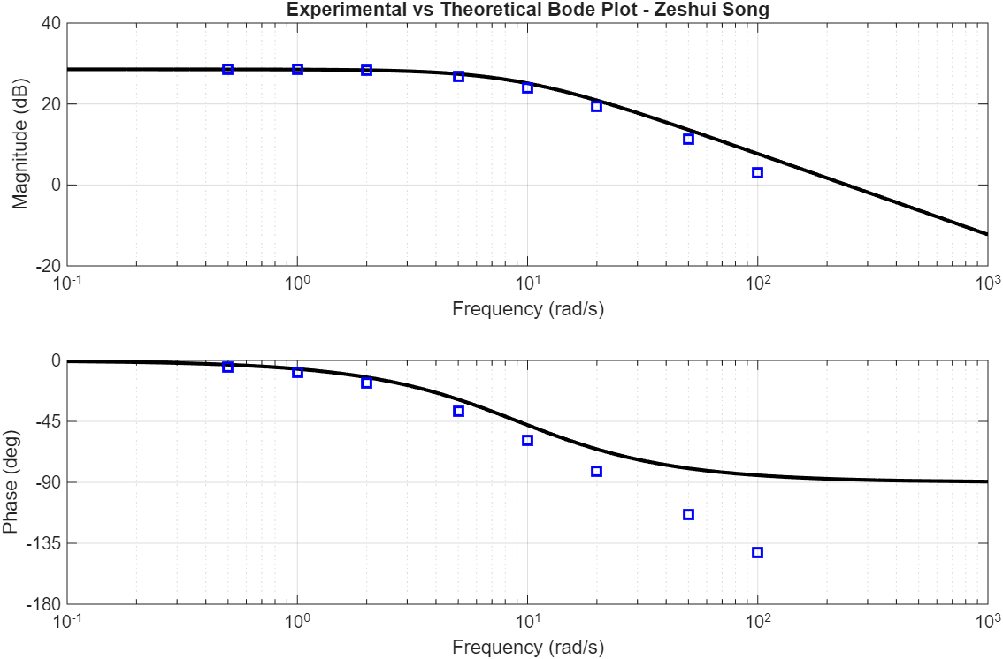

- Briefly discuss the comparison and if there are any discrepancies between the model and experimental results, include any factors that may contribute to the differences.
- The experimental results match the theoretical first order model well for low frequencies but start to deviate for higher frequencies, especially with the phase lag. Instead of becoming asymptotic to -90 deg, it keeps decreasing.
- Extra Credit: Determine a second-order model using the inductance given in the Qube-Servo-2 User Manual and an estimated damping value, B, ensuring the overall gain closely matches the experimental low frequency gain. Submit an additional plot comparing your experimental results with your second-order model of the motor. Discuss the fit and any differences in the magnitudes, phases, and corner frequencies. Include the parameters used for your second-order model and show the model in transfer function form. Discuss whether the first-order or second-order model seems more appropriate.

4 Deliverables
- Answers to the numbered questions.
- Table of gain and phase values at different input frequencies.
- Comparison of the theoretical and experimental frequency response. Two Matlab plots are to be included: one for magnitude in dB and one for phase in degrees, with both the theoretical model and the experimental data points clearly shown on each.

Note, the MATLAB Bode plot function by default plots the magnitude in dB where $M[dB]=20log\frac{M}{Mref}$ and the reference magnitude M_{re f} = 1, thus $M[dB]=20logM$. For example, a magnitude of 10 is 20dB, 100 is 40dB, 2 is 6dB, 0.5 is -6 dB, and 1/√2~0.707~-3 dB.

